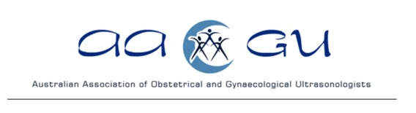

August 24-25, 2024 Adelaide
Mt Lofty House

DAY 1 | SATURDAY AUGUST 24th
8.45-9.15 | Registration and Coffee
9.15-9.30 | Welcome
9.30-10:00 | Twin Twin Transfusion Syndrome: Evolution of the Laser Surgery Technique | Professor Chmait
10.00-10.30 | Fetal Lung Lesions | A/Prof Palma-Dias
10.30-11.00 | How do we treat TAPS: a fetal surgeon’s perspective | Professor Chmait
11.00-11:30 | MORNING TEA
11.30-12.30 | Evaluation of Adnexal Masses | Dr Mala Sibal
12.30-1.00 | Vasa Praevia: Diagnosis and Management | Professor Chmait
1.00-2.00 | LUNCH
2.00-2.30 | Adnexal Masses in Pregnancy | Dr Mala Sibal
2.30-3.00 | Fetoscopic repair of Open Spina Bifida | Professor Chmait
3.00-3.30 | Trio Exome | Professor Barnett
3.30-4.30 | AFTERNOON TEA AND WINE TASTING | Hylton McLean
4.30-5.30 | AAOGU AGM | Dr Jane Woolcock

DAY 2 | SUNDAY AUGUST 25th
9.00-9.30 | COFFEE
9.30-10.00 | Deep infiltrating Endometriosis | Dr Mala Sibal
10.00-10.30 | MRI for the Diagnosis of Endometriosis | Dr Steven Knox
10.30-11.00 | Extra Pelvic Endometriosis | Dr Mala Sibal
11.00-11.30 | MORNING TEA
11.30-12.15 | Adenomyosis | Dr Mala Sibal
12.15-1:00 | The Importance of Adenomyosis in Fertility | Dr Sally Reid
1.00-2.00 | LUNCH
2.00-2.30 | Case Review and Discussion Adenomyosis | PANEL
2.30-3.00 | Feedback
 | Review and Reflection

